Hello, my name is Mr. Chan and I will be one of your teachers in Foundation Class at Stuart Road Primary Academy.
This is a picture of myself with my partner, Rachel.
I have two children called Phoebe and Joseph who are both in secondary school.
In my spare time I enjoy watching films, my favourite films are super hero ones! My favourite superhero is Batman.

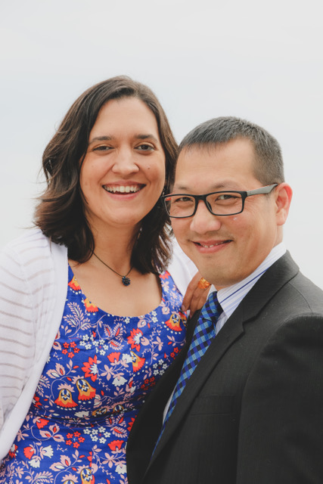

I also like to stay fit and healthy by going to the gym and playing badminton with Joseph.

