Starting School

My name is
……………………………….
The name of my school is
……………………………….

Dear Parents/Carers

Starting primary school is a significant milestone in any child’s life and is often both exciting and challenging, however, due to Covid 19, the normal preparations for your child starting school will be additionally challenging. We have prepared some resources, including links and activities, that we hope may be of use to you during the coming weeks.

The 8 different areas covered will include:-

Finding out about my new school

Practical preparation (social/independence skills)

Practical preparation (home learning)

Emotional preparation

Making new friends

Counting down and final week

Preparing yourself

First Day

Finding out about my new school

Draw a picture of your new primary school

Draw a picture of how you will travel to school……………

Session 1
To help familiarise your child with their new school search the school website and look at pictures together with your child or download their prospectus if there is one available. On the website it may show pictures of children undertaking activities within the school building and grounds and key members of staff that may be teaching or have links with your child once they start.

Normal visits for foundation children to look around may not be possible at the moment and it might be worth checking the school website to see if any virtual tours of the school are available to look at to gain familiarisation with the building. If your child’s school do not have a virtual tour show your child the link below for a general tour of a primary school as shown by two primary aged children.
https://www.bbc.co.uk/bitesize/articles/z4v792p
Other activities

Use the time between now and when your child first starts school to create an ‘All about me’ scrapbook to show their new teacher and classmates. The book could include drawings/photos of themselves and things they have collected such as achievements certificates at nursery or pre-school, special paintings or anything to do with their interests.

If your child does not want to complete a scrapbook you could use the link below to print and complete an ‘All about me’ worksheet which can also be shown to your child’s teacher or kept in their memory box.

http://teach.files.bbci.co.uk/startingprimaryschool/all_about_me_worksheet.pdf

Session 2 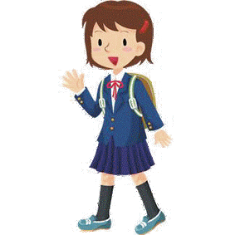

Practical Preparation (Social/independence skills)

As parents/carer’s you may wonder what you need to teach your child in preparation for school readiness. Some of the most important things to support your child with prior to them starting school will be encouraging them to do the following things for themselves.

Managing snack and mealtimes (using a knife and fork)
Dressing and undressing
Going to the toilet and hand washing
Recognising and organising their own belongings
Putting up their hand to ask questions
Sitting down with their legs crossed and hands in their lap
Managing ties and shoelaces (Velcro shoes are easier)
Tidying up their toys
Helping with simple chores

The links below highlight some of the above and provides a video for practising with ties and some tips from an early year’s specialist.

https://www.bbc.co.uk/bitesize/articles/zvxj47h

https://www.bbc.co.uk/bitesize/articles/zrg8gwx

In support of this session decide with your child what they would like to practise over the coming few weeks and maybe create a chart to show when they have completed their challenge.

Session 3

Practical Preparation (home learning)

Children have a natural curiosity about their surroundings and can often be asking the ‘why’ question. Talking to your child and reading to them are two great ways to support your child’s development. Sharing books in a fun and interactive way can help to develop their love of stories and books, this is more of a priority at this stage than letter recognition. When reading stories talk about the characters encourage your child to act out parts of the story with their own toys or puppets and explore what the characters might be feeling.

Through everyday activities such as cooking, gardening and messy play many skills can be built up and strengthened, such as fine motor skills, in readiness for school. Preparing food and cooking with your child will help their understanding of maths through weighing and measuring and using utensils. Cooking also involves science such as what happens to ingredients when they are heated or cooled. Messy play both indoors and outside will help develop many aspects of learning, for example painting can help expression of emotions through choice of colours. If you are interested in some creative ideas of what you can do with your child check out the link below for ideas.

https://www.bbc.co.uk/cbeebies/makes
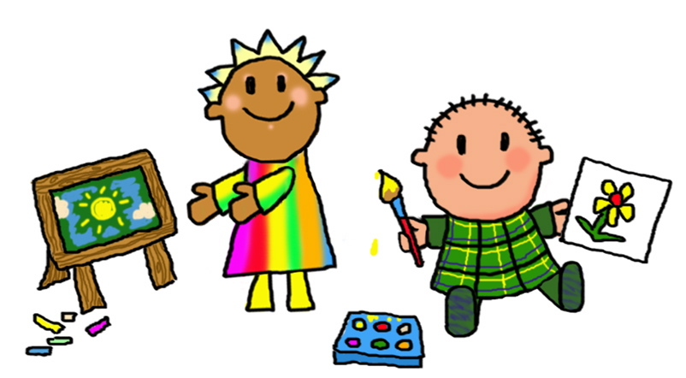

Gardening, whether you have a large outside space or just a window box is another great learning activity you can undertake together. Children love to watch plants grow and gardening can be a helpful activity for reducing stress and developing your child’s self-esteem. Maybe photographs of the development of the plant from a seed to seedling to full grown plant could be taken and included in your child’s scrap book of activities undertaken during the build up to starting school. For a variety of ideas look up the following links from jumpstart.

https://www.jumpstart.com/common/planting-seeds-for-success

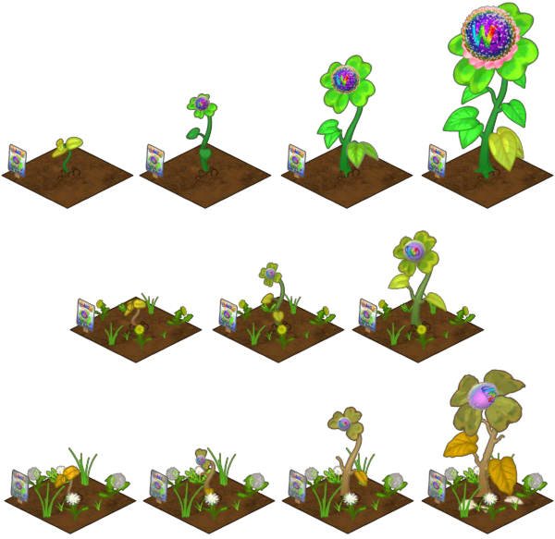

Session 4

Emotional preparation
Much of the practical preparation you undertake with your child will also help to prepare your child emotionally for school. Young children can struggle with things that are not tangible, therefore, raising their confidence levels by being prepared practically will improve their ability to cope with what is expected of them at school. All children are individuals and will cope with the build up to school differently and they will also pick up on the emotions of the adults around them, therefore, in section 7 we have included some ideas on how to manage your own feelings about your child starting school.

- Using a variety of resources that introduce your child to school and make familiar the aspects of the school day will help them emotionally as they begin the physical process of transitioning into school. Looking at photographs of school children, reading books, watching online video clips and television programmes can all contribute towards your child’s understanding of what it will be like at school. Also undertaking role play of the different aspects of a school day will help them to feel more confident. Ideas for role play could include some or all of the following:-
Taking the register
Lunchtime
Playtime
PE lessons
Recognising their name label

Check out this BBC clip for suggestions:-
https://www.bbc.co.uk/bitesize/topics/zhtcvk7/articles/znc9vk7

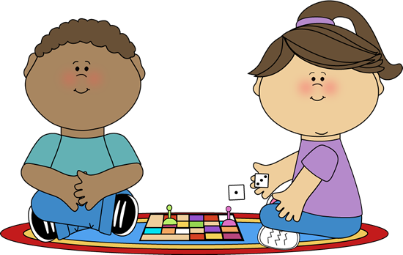
In every area of preparation encourage your child as they face new challenges and recognise the small steps they take towards their goals.

Listen to some top tips by a clinical psychologist on Bitesize on growth mindsets.

https://www.bbc.co.uk/bitesize/articles/zf3vvk7

Be positive with your child and value the process of learning, not just the outcomes, remembering that children learn best when they are having fun.

Further tips on building resilience can be found on the link below.

https://www.bbc.co.uk/bitesize/articles/zbbrrj6

Why not have a go at making a feelings register with your child to help them begin to recognise different emotions.

https://www.elsa-support.co.uk/wp-content/uploads/2020/04/Emotional-register-under-5s.pdf

Session 5
Making new friends

Most children will have attended an early years setting such as nursery or pre-school before their reception year. There may well be children who are at their current setting that will have a place at the same school and that could provide opportunities for playdates to help build friendships prior to starting school. However, in the current situation that may not be possible before school starts, therefore, we have listed a few ideas below on helping to develop your child’s friendship skills.

- Develop empathy through role modelling positive behaviour and reinforce through noticing and praising kind behaviour.

- Help your child understand boundaries and why they are important. Playing games involving turn taking and following rules can help with this.

- Develop social skills through encouraging politeness, role playing with teddies and favourite toys and allowing your child to resolve squabbles with siblings where possible.

https://www.bbc.co.uk/cbeebies/grownups/help-your-child-make-friends-at-primary-school

An activity to try on the ELSA website during lockdown.
https://www.elsa-support.co.uk/friends-little-book/

Session 6
Counting down and final week
There are a number of practicalities in preparing your child for starting school. The weeks leading up to the school start date can be a good time for building new routines. In the information below there is reference to bedtimes, making journals, uniforms and countdown calendars. There is further information on a variety of preparation topics in the Pacey.org link below.
https://www.pacey.org.uk/partnerships/starting-school-together/preparation/

Making a journal/scrapbook together
Creating a journal or diary together over the summer can be helpful for when your child’s starts school. You could use bath time or dinner time to chat to your child about what has happened during the day or week and then record in the book. You could use pictures or photographs and write next to them what has happened, with your child making marks underneath your writing.

Sleep routines
Establishing a good bedtime routine, if not already in place, can be really helpful in the build up to the big day. Having time to wind down is important for your child and bath time and reading books together can be relaxing activities. Children can find the early weeks of school tiring as there will be lots of new information for them to take on board so being in a regular pattern at bedtime should be beneficial. Check out the link below from Bitesize with a video clip from an expert sleep consultant.
https://www.bbc.co.uk/bitesize/articles/znhyt39

Timelines and countdown calendars

Children can find it difficult to have a concept of time and if they are becoming anxious around the build up to school creating a visual display of the dates may help. If you make a calendar involve your child with the activity and decorate it with pictures and images of their interests or favourite characters. You could decide to put a tick or sticker on each day to enable your child to see how long until the big day. The link below on the ELSA support site will give you some ideas and there is a blank template attached with this session if you prefer.
https://www.elsa-support.co.uk/wp-content/uploads/2020/01/Timelines.pdf

Final week

Hopefully all the practical preparation will have been completed beforehand to enable both you and your child to enjoy the final week together. Ideally relaxing and having fun in the last few days before school will assist your child to make a calm start without any last minute stress of buying uniforms and resources. Allow your child to become familiar with their uniform maybe trying it on and wearing it around the house with their school shoes so they can adjust to it before the first day. Getting out for some exercise and walking past the school, familiarising yourselves, in the days leading up will all help towards making the first day more manageable.
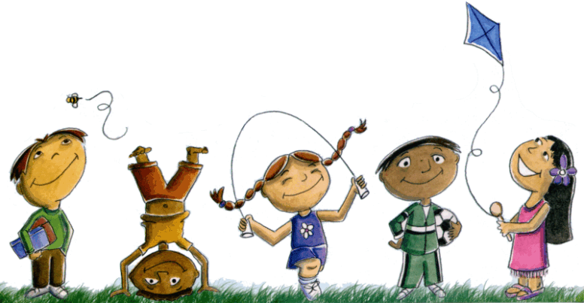

My school count down and memory calendar
Monday | Tuesday | Wednesday | Thursday | Friday | Saturday | Sunday

Session 7
Preparing yourself

Although it may be an anxious time for your child as they begin school for the first time it can, understandably, also be an anxious time for parents and carer’s. Children are all individuals and some may walk into school apparently confidently other’s may cling on to their adults and say that they do not want to go. It is, therefore, really important that during the build-up you remain positive about starting school and encourage your child to think about all the new and exciting things they will experience when they start.

Be prepared yourself by researching the school website and reading information sent by the school. You will feel more confident if you know what to expect and your child will pick up on this. Most schools encourage parents/carer’s to label all their children’s uniform and belongings and as mentioned previously it will be less stressful if this is completed in advance.

With all the practical preparation completed trying to ensure you look after yourself emotionally is as important for you as it is for your child. An early night and planning to get up before your child to ensure you have at least a little time for yourself can be helpful for your wellbeing. Allowing your child to become independent with being able to access some aspects of getting breakfast will help with timescales particularly if you have more than one child to get ready.

If your child has additional needs or you have concerns about their development the school will have a senco (special educational needs co-ordinator) and if you are a carer the school will also have a DT (designated teacher) for all children in care or previously looked after. Some schools also have a PSA (parent support advisor) who may help with issues around uniform, behaviour and support you during meetings with teachers and other professionals.

Being involved with your child’s school by attending special assemblies, parent’s evenings and social events can all have a very positive impact on your child. If you are able there are a number of ways to become involved with your child’s school including the PTA (parent and teacher association), volunteering to help i.e. with reading/school trips etc. and being a parent governor. Finding out if there is an online parent’s group may also be another way to build relationships yourself as this could be beneficial when sharing ideas and resources for school projects, costume days etc. and hopefully become a helpful support network.

Session 8
First Day
Some schools may have a staggered transition timetable beginning with just mornings and gradually building up to including lunchtime and finally staying all day. Closer to the start date your child’s school should inform you of the transition plan. If you are not able to drop your child on the first day, due to work or other commitments, inform the school who will be dropping off/collecting your child. If you are not able to be with your child on their first day, school permitting, suggest to whoever is taking them, to take photos or videos that can be shared with you later.

Allow extra time on the first day in case of any last minute delays and so you can arrive at the school in plenty of time. If you are able to walk to school this may be a good time to chat about anything your child is anxious about and reinforce that you will be looking forward to hearing about everything they have done. Where you say goodbye to your child will depend on the particular school and can be discussed with the school beforehand. Being calm yourself and reassuring your child with positive comments and focus on the fun and excitement of starting school will help them to feel relaxed.

https://www.bbc.co.uk/iplayer/episode/p07jt1gd/time-for-school-songs-1-get-ready

In the clip below Topsy and Tim talk about their first day at school, you might like to use this video to reassure your child that other children are likely to feel the same as them. The video clip might also prompt some helpful discussions with your child.

https://www.bbc.co.uk/cbeebies/curations/starting-school-curation

The attached sheet can be printed and completed as a record of your child’s first day with a photo added in the box or maybe your child could draw a picture.

My first day at school

Date……………………………………………………

My school is……………………………………………

My uniform is………………………………………….

My teacher is called………………………………….

This is a picture taken of me on my first day.

