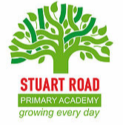

Stuart Road Primary Academy
Palmerston Street
Stoke
Plymouth
PL1 5LL

Tel: 01752567668
Email: admin@srps.plymouth.sch.uk
Website: www.stuartroad.org

Friday, 21st May 2021
Dear Parent / Carer,
In Term 6 our focus for Personal, Social and Health Education will be ‘Changing Me’ this will be delivered using Jigsaw. Within this topic we will be learning about how we change as we grow up and about relationships. This is part of the Relationship and Sex Education (RSE) curriculum that became statutory in September 2020.
Some of the areas covered are quite sensitive and personal and as such it is imperative that your child is fully supported by us all. As parents and carers you need to be informed so that you can support them throughout the ‘Changing Me’ topic.
Below are the key learning outcomes for Year 4
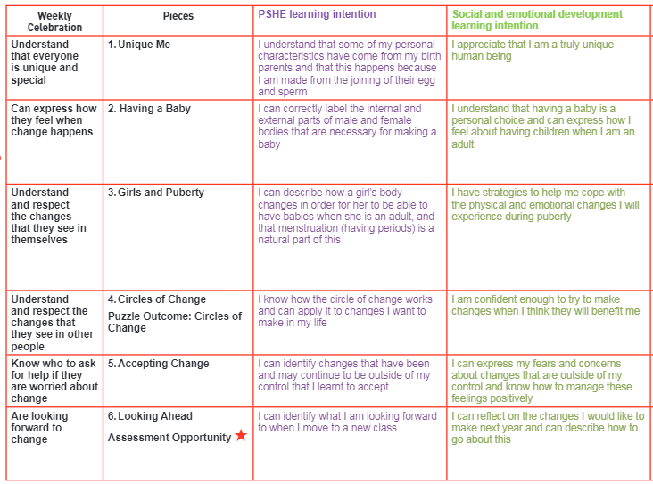
If you have any queries please contact your child’s class teacher. If you would like to view some of the resources that will be used in school I will be holding a virtual session on Thursday 27th May 2021 between 2pm-2.30pm. If you would like to attend please confirm this to admin@srps.plymouth.sch.uk and a Zoom invite will be sent. Please email any questions you may have, to the admin address, by Tuesday, 25th May.
Best wishes
Britta Nicholls
Acting Head of School
Stuart Road Primary Academy

