We want your child to love reading - and to want to read for themselves. This is why we put our efforts into making sure they develop a love of books as well as simply learning to read.
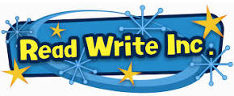
We start by teaching using the RWI (Read, Write, Inc) programme to the children in Reception and this continues until they are ready to exit the programme. This means that each child learns how to 'read' the sounds in words and how these sounds can be written down. This is essential for reading, but it also helps children learn how to spell well. We teach children simple ways of remembering these sounds and letters.
The children also practise reading (and spelling) what we call 'tricky words', such as 'once' and 'said'. They practise reading with books that match their phonics and the 'tricky words' they know. They start believing in themselves as successful readers and this does wonders for their confidence.
Children who have successfully completed the programme move on to RWI spelling which covers all the rules to meet their year group expectations. Pupils at Stuart road Primary Academy love these sessions as they complete a variety of activities and work with a partner in a fun and engaging way.
At Stuart Road Primary Academy, Teachers, TAs, adults and older pupils read to the children too, so they get to know all sorts of stories, poetry and information books. They learn many more words this way and it also helps their writing.
Mrs Hannon
RWI Lead

