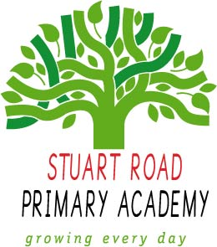

Stuart Road Primary Academy
Palmerston Street
Stoke
Plymouth
PL1 5LL

Tel: 01752567668
Email: admin@srps.plymouth.sch.uk
Website: www.stuartroad.org

26th November 2021
Dear Parents & Carers
Re: Ofsted Report
It give me great pleasure to share with you the Ofsted report from our recent inspection.
Over the two day’s inspection the HMI recognised and reported on many positive aspects that you can read in the report.
Stuart Road Primary continues to be judged a good school, with the Inspector recognising the high quality provision of our English and maths curriculum, in particular the well-designed reading curriculum, and clear, systematic teaching of mathematics.
The report goes on to state how well pupils behave in lessons, concentrating on their learning and understanding what is expected of them. The use of pupil voice is celebrated as this helps them to understand and value democracy. Safeguarding is effective with staff vigilant and quick to report any concerns.
I hope that you also agree what a wonderful, talented staff we have here at Stuart Road, who put the quality of education and well-being of your child first.

With very best wishes,
Headteacher: Mr Mitch Frame

Britta Nicholls
Head of School
Stuart Road Primary Academy

