**Engage –** Meet John Doe

**Innovate –** Forensic crime scene

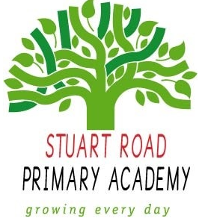

**Stuart Road Academy Geography Curriculum**

**Termly Overview**

**Year 6 Term 1**

**ID**

**Unit Overview**

Develop children’s knowledge of classification and inheritance. Children explore human identity, genetic characteristics, family traits and their own values and beliefs.

**Cross-curricular links**

|  |  |
| --- | --- |
| **English** | Descriptions and narratives; Non-chronological reports;  Adverts; Facts, opinions and tributes; Calligrams |
| **Science** | Classification; Families and inheritance; Working scientifically |
| **A&D** | Portraiture and figurines |
| **Computing** | Software; Photo stories; E-safety |
| **D&T** | Tools and equipment; Design; Fashion and clothing |
| **Geography** | Community |
| **History** | Social reformers |
| **Music** | Appraising; Listening to voices |
| **PSHE** | Identity, personal views and opinions; My place;  Recognising strengths |
| **PE** | Physical challenges |

**Knowledge, Skills and Concepts**

* **Geographical skills and fieldwork**

1. Use the eight points of a compass, four and six-figure grid references, symbols and key (including the use of Ordnance Survey maps) to build their knowledge of the United Kingdom and the wider world.
2. Use fieldwork to observe, measure, record and present the human and physical features in the local area using a range of methods, including sketch maps, plans and graphs, and digital technologies.

**Assessment**

Children will be able to use maps, compass points and grid references.

**Local Geography links**