**Engage –** Mummification scene

**Innovate –** Egyptian funeral preparations

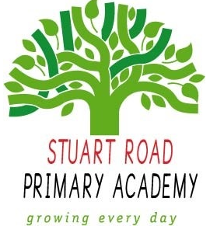

**Stuart Road Academy Geography Curriculum**

**Termly Overview**

**Year 5 Term 1**

**Pharoahs**

**Unit Overview**

Develop children’s knowledge of ancient Egypt. Teach children about life on the Nile, the great pyramids and the powerful rule of the ancient pharaohs.

**Cross-curricular links**

|  |  |
| --- | --- |
| **English** | Chronological reports; Fact files; Research skills;  Mystery stories; Play scripts |
| **History** | Ancient Egypt |
| **A&D** | Drawing artefacts; Headwear; Hieroglyphic amulets |
| **D&T** | Egyptian food; Making tombs and pyramids |
| **Geography** | Human and physical features of Egypt; The River Nile; Tourism |
| **PSHE** | Moral issues; Customs and beliefs; Role play |

**Knowledge, Skills and Concepts**

* **Locational knowledge**

1. Locate the world’s countries, using maps to focus on Europe (including the location of Russia) and North and South America, concentrating on their environmental regions, key physical and human characteristics, countries, and major cities.

* **Geographical skills and fieldwork**

1. Use maps, atlases, globes and digital/computer mapping to locate countries and describe features studied.

* **Aims and purpose**

1. Understand the processes that give rise to key physical and human geographical features of the world, how these are interdependent and how they bring about spatial variation and change over time.

**Assessment**

Children will be able to use maps to locate countries and describe their features.

**Local Geography links**