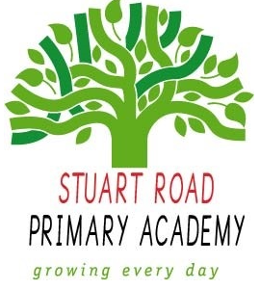

**Stuart Road Academy Science Curriculum**

**Termly Overview**

**Year 5 Term 1 – Pharaohs**

**Engage – Clive Pig Pharaoh Death Ceremony**

**Innovate – Mummification and Sarcophagus**

**Unit Overview**

Let’s travel back 5000 years, to the dusty realms of ancient Egypt. Find out about life on the river’s fertile banks, discovering Egypt and its fascinating culture. Unravel the secrets of ancient tombs, using historical sources and ancient artefacts. Become an apprentice and work for Ramose, the chief embalmer at the Beautiful House. Help him prepare a body for its journey into the afterlife. Now open the doorway to ancient Egypt. Who knows what treasures you will find?

**Cross-curricular links**

**History – Ancient Egypt**

**Geography – Where is Egypt?**

**Art and design – Hieroglyphics**

**D.T. -Building pyramids**

**Knowledge, Skills and Concepts**

Explore boats on the River Nile to:

* identify the effects of air resistance, water resistance and friction, that act between moving surfaces
* recognise that some mechanisms including levers, pulleys and gears allow a smaller force to have a greater effect

Explore the mummification process to:

* know that some materials will dissolve in liquid to form a solution, and describe how to recover a substance from a solution (Mummification)

**Assessment**

The children will be able to able to identify different forces, understand how levers, pulleys and gears work and know that some materials dissolve in liquid.

**Local Science links**

IMechE Cardboard Boat Race