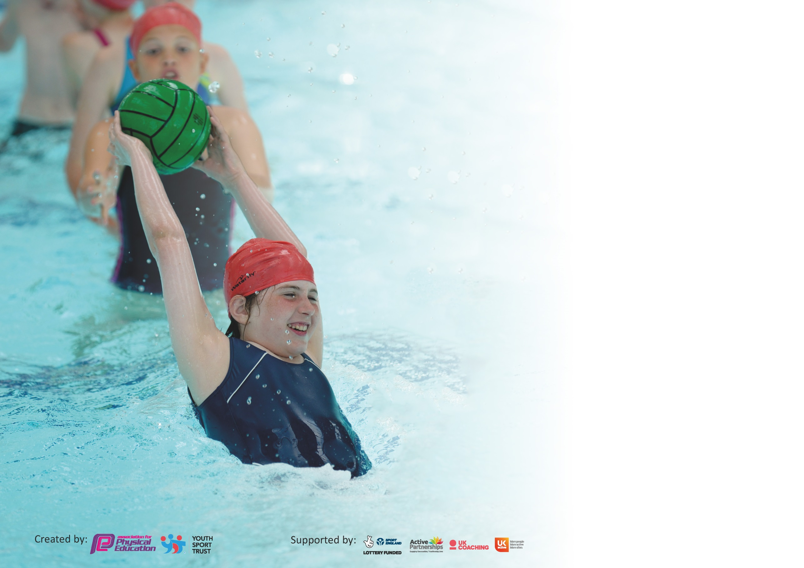

It is important that your grant is used effectively and based on school need. The Education Inspection Framework (Ofsted 2019 p64) makes clear there will be a focus on ‘whether leaders and those responsible for governors all understand their respective roles and perform these in a way that enhances the effectiveness of the school’.

Under the Quality of Education criteria (p41) inspectors consider the extent to which schools can articulate their curriculum (INTENT), construct their curriculum (IMPLEMENTATION) and demonstrate the outcomes which result (IMPACT).

To assist schools with common transferable language this template has been developed to utilise the same three headings which should make your plans easily transferable between working documents.

Schools must use the funding to make additional and sustainable improvements to the quality of Physical Education, School Sport and Physical Activity (PESSPA) they offer. This means that you should
use the Primary PE and Sport Premium to:

- Develop or add to the PESSPA activities that your school already offer
- Build capacity and capability within the school to ensure that improvements made now will benefit pupils joining the school in future years

Please visit gov.uk for the revised DfE guidance including the 5 key indicators across which schools should demonstrate an improvement. This document will help you to review your provision and to report your spend. DfE encourages schools to use this template as an effective way of meeting the reporting requirements of the Primary PE and Sport Premium.

We recommend you start by reflecting on the impact of current provision and reviewing the previous spend.

Schools are required to publish details of how they spend this funding as well as on the impact it has on pupils’ PE and sport participation and attainment by the end of the summer term or by 31st July 2020 at the latest.

We recommend regularly updating the table and publishing it on your website throughout the year. This evidences your ongoing self-evaluation of how you are using the funding to secure maximum, sustainable impact. Final copy must be posted on your website by the end of the academic year and no later than the 31st July 2020. To see an example of how to complete the table please click HERE.

Support for review and reflection - considering the 5 key indicators from DfE, what development needs are a priority for your setting and your pupils now and why? Use the space below to reflect on previous spend and key achievements and areas for development.

Key achievements to date until July 2019: | Areas for further improvement and baseline evidence of need:
- Achieved Silver Award with School Games Mark 2019.  - Development of high quality CPD for all teaching staff in PE lessons.  - School football team achieved 6th in Plymouth Primary Schools football League- team equipped with sponsored kit supplied (cost supplemented) by a local business.  - Participated in Level 3 competition for Rounders event at Devon School Games and Athletics at Brickfields with other Plymouth Schools.  - Participated in Plymouth Primary Schools Athletics meet at Brickfields- 2 children placed in finals & boys relay team competed in finals.  - Attended Indoor Athletics events for LKS2 and UKS2.  - Participated in local Quadkids events.  - Participated in Netball Tournament.  - Established Netball & Tag Rugby festival with sister school within the REACH South MAT. | - Maintain Silver Award with School Games Mark- look into achieving Gold with increasing range of competitive sport and provision of clubs for the least active.  - Development of after school club (sports based) clubs.  - Provision of a Change for Life Club (targeting inactive children)  - Development of a positive attitude to physical activity at lunchtimes & sports leaders- CPD to be provided by a sports coach for Meal Time Assistants (MTAs).  - Increase range of sports festivals with sister school within REACH South MAT.

Meeting national curriculum requirements for swimming and water safety.
What percentage of your current Year 6 cohort swim competently, confidently and proficiently over a distance of at least 25 metres?  N.B. Even though your pupils may swim in another year please report on their attainment on leaving  primary school at the end of the summer term 2020. | %
What percentage of your current Year 6 cohort use a range of strokes effectively [for example, front crawl, backstroke and breaststroke]? | %
What percentage of your current Year 6 cohort perform safe self-rescue in different water-based situations? | %
Schools can choose to use the Primary PE and Sport Premium to provide additional provision for swimming but this must be for activity over and above the national curriculum requirements. Have you used it in this way? | Yes/No

Action Plan and Budget Tracking
Capture your intended annual spend against the 5 key indicators. Clarify the success criteria and evidence of impact that you intend to measure to evaluate for pupils today and for the future.

Academic Year: 2019/20 | Total fund allocated: £ 17,540 | Date Updated: 04-12-19
Key indicator 1: The engagement of all pupils in regular physical activity – Chief Medical Officer guidelines recommend that primary school pupils undertake at least 30 minutes of physical activity a day in school |  |  |  | Percentage of total allocation:
 |  |  |  | 51%
Intent | Implementation |  | Impact | End of year review
Your school focus should be clear what you want the pupils to know and be able to do and about  what they need to learn and to  consolidate through practice: | Make sure your actions to achieve are linked to your intentions: | Funding allocated: | Evidence of impact: what do pupils now know and what can they now do? What has changed
Provide MTAs with CPD by a qualified sports coach to engage children in physical activities during lunch times.  Provision of after school PE based clubs every day of the school week. | Employ sports coaches to support MTAs with engaging children in physical activity.  Employ sports coaches to run after school PE clubs for Key Stage One and Key Stage Two children. | £5130  £3800 | More children engaging in physical activity and increase in positive behaviour during lunch times.  Five clubs available five days per week.
Key indicator 2: The profile of PESSPA being raised across the school as a tool for whole school improvement |  |  |  | Percentage of total allocation:
 |  |  |  | 23%
Intent | Implementation |  | Impact | End of year review
Your school focus should be clear what you want the pupils to know and be able to do and about  what they need to learn and to  consolidate through practice: | Make sure your actions to achieve are linked to your intentions: | Funding allocated: | Evidence of impact: what do pupils now know and what can they now do? What has changed?
Provide children with opportunities to compete in city-wide sporting events linked with PE curriculum in school.  Provide children access to new sporting opportunities, experiences and resources.  Access to BIKEABILITY and BALANCEABILITY for Year Six and Foundation Class (respectively)  Replenish and replace PE equipment to support the PE curriculum in school. | Continued membership with Plymouth Schools’ Sports Partnership (PSSP)- allowing access to competitions organised across the city.  Through PSSP membership- utilise access to resources such as Frisbee golf, indoor curling, dance mats etc.  Sessions booked for both Foundation Class and Year Six class.  Ensure that resources are fit for purpose in the delivery of the PE curriculum in school. | £3500  Inclusive of PSSP membership.  Inclusive of PSSP Membership  £500 | More children will access inter school competitions.  Children will engage in a wider variety of sporting activities.  Foundation Class will develop ability to balance on a bike. Year Six will ride a bike safely and on public roads.

Key indicator 3: Increased confidence, knowledge and skills of all staff in teaching PE and sport |  |  |  | Percentage of total allocation:
 |  |  |  | 12%
Intent | Implementation |  | Impact | End of year review
Your school focus should be clear | Make sure your actions to | Funding | Evidence of impact: what do
what you want the pupils to know | achieve are linked to your | allocated: | pupils now know and what
and be able to do and about | intentions: |  | can they now do? What has
what they need to learn and to |  |  | changed?
consolidate through practice:
Provision of a qualified sports coach to support the development of physical activity for Foundation Class.  Support staff with subject knowledge and confidence in delivery of the PE curriculum. | Sports coach to support Foundation Class staff in teaching of PE.  Arrange support from PE department at Stoke Damerel Community College (via PSSP) in supporting staff in delivery of PE curriculum). | £2090  Inclusive of PSSP membership. | Increased confidence and subject knowledge by staff in the delivery of the PE curriculum).
Key indicator 4: Broader experience of a range of sports and activities offered to all pupils |  |  |  | Percentage of total allocation:
 |  |  |  | 6%
Intent | Implementation |  | Impact | End of Year review
Your school focus should be clear | Make sure your actions to | Funding | Evidence of impact: what do
what you want the pupils to know | achieve are linked to your | allocated: | pupils now know and what
and be able to do and about | intentions: |  | can they now do? What has
what they need to learn and to |  |  | Changed?
consolidate through practice:
Allow Disadvantaged children to access sporting events which incur costs.  Provide children with a broader range of sports activities.  Inform parents, children and the wider school community of extra-curricular clubs via the school noticeboard and school website. | Cover the cost of entry to the Plymouth Schools’ Challenge Run (in May 2020)  Access to PSSP supported activities such as Outdoor Adventure Activities, resources (such as Frisbee golf, indoor curling).  Organise an Activities Week in conjunction with High Street Primary Academy.  Promote clubs available in the community via flyers or on the school website. | £50  Inclusive of PSSP membership.  £1000  FREE OF CHARGE | Disadvantaged children having the opportunity to participate in the Schools’ Challenge Run event.  Children having the opportunity to engage in new physical activities.  Increase in number of children engaging in physical activity outside of school and in the community.

Key indicator 5: Increased participation in competitive sport |  |  |  | Percentage of total allocation:
 |  |  |  | 6%
Intent | Implementation |  | Impact | End of year review
Your school focus should be clear | Make sure your actions to | Funding | Evidence of impact: what do
what you want the pupils to know | achieve are linked to your | allocated: | pupils now know and what
and be able to do and about | intentions: |  | can they now do? What has
what they need to learn and to |  |  | changed?
consolidate through practice:
Engage in a variety of sporting competitions against children from other schools.  Engage in termly competitions against ‘sister’ school within REACH South MAT.  School football team to participate in a league competition. | Book entry to city wide competitions via the PSSP website.  Organise competitions with PE coordinator at High Street Academy.  Participate in Primary Schools’ Football League 2019-2020 season.  Supply staff may be required to release school teaching staff to supervise the children at these events. | Inclusive of PSSP membership.  £55 (membership fee)  £1000 | More children having the opportunities to engage in competitive inter-school sport.

