Science Curriculum Map
 | Autumn 1 | Autumn 2 | Spring 1 | Spring 2 | Summer 1 | Summer 2
Reception | Seasons  Life cycle – baby (Nativity story link) |  | New beginnings  Plants & seeds  Healthy eating – rainbow plate |  | Life cycle - butterfly | Habitats – rock pools & creatures of the deep
Year 1 | Everyday Materials  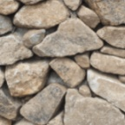 | Human Senses  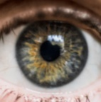 | Seasonal Changes  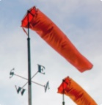 |  | Plant Parts  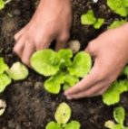 | Animal Parts
Year 2 | Human Survival |  | Animal Survival  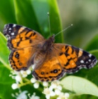 | Habitats  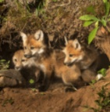 | Uses of Materials  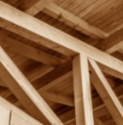 | Plant Survival  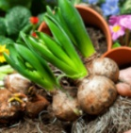
Year 3 | Skeletal and Muscular Systems  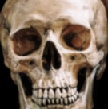 |  | Forces and Magnets  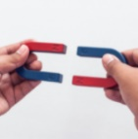 |  | Plant Nutrition and Reproduction | Light and Shadows  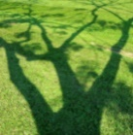
Year 4 | Digestive System  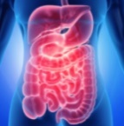 | Sound  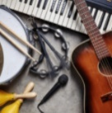 | States of Matter  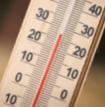 | Grouping and Classifying  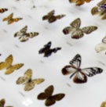 | Electrical Circuits and Conductors  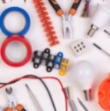
Year 5 | Properties and Changes of Materials  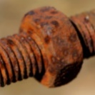 |  | Human Reproduction and Ageing  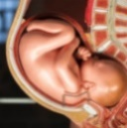 |  | Forces and Mechanisms | Earth and Space  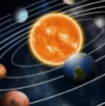
Year 6 | Electrical Circuits and Components  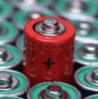 |  | Light Theory  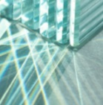 | Evolution and Inheritance  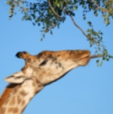 | Circulatory System  